**9-2 Model fitting to data using MLE**

**PART I: Fitting the catalytic model to seroprevalence data to estimate the force of infection**

We will first analyze the data from the UK (“seroprevalence_uk”):

Ignoring the maternal antibodies, write the formula for the proportion of age “a” who have ever been infected in terms of force of infection “”. Fit the catalytic model to seroprevalence data to estimate the force of infection using MLE in which Binomial distribution is assumed for the data.

1. Assume the initial value for the force infection in the UK to be 0.1. Do you think the true value for the force infection in the UK was greater or smaller than that currently assumed? What is the current value for negative log-likelihood?

* Plot for a data and prediction plot when force of infection is 0.1

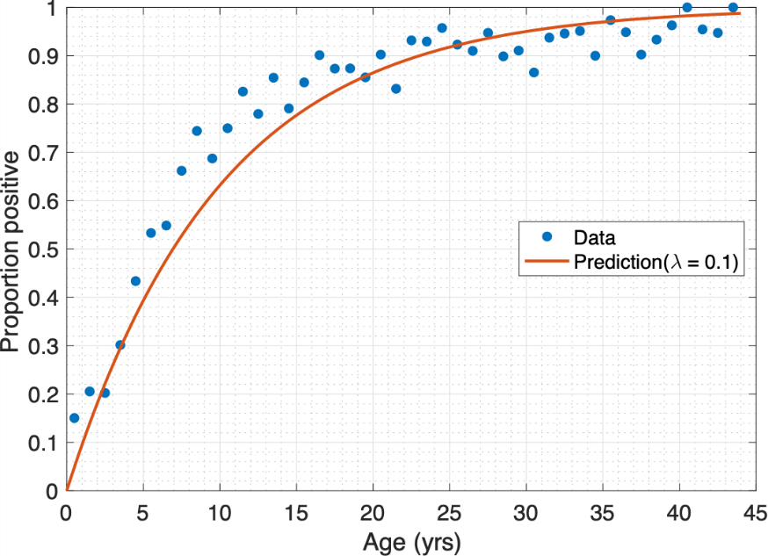

* It seems like under-estimation, so the true for the force of infection in the UK is greater than 0.1
* Current value for negative log-likelihood : 171.480347

1. Plot a graph of negative log-likelihood. What is the best-fitting value for the force of infection and the 95% confidence interval? What is the current value for negative log-likelihood?

* Plot for negative log-likelihood

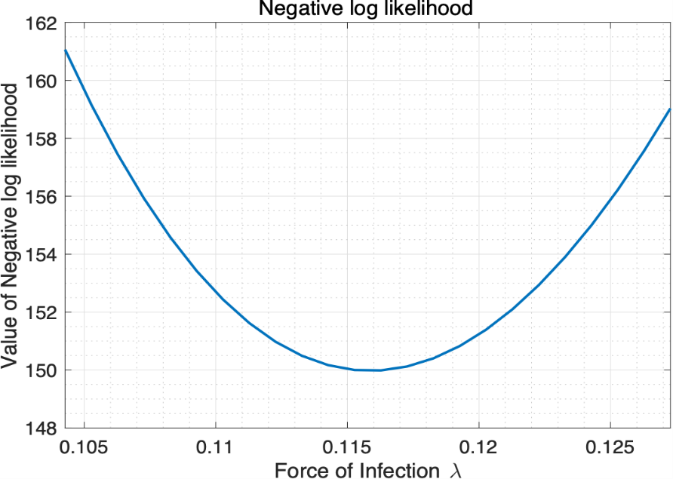

* Best-fitting value of force of infection : 0.115859
* 95% confidence interval : [0.110912 0.121005]
* Current value of negative log-likelihood : 149.975487

1. Calculate the average age at infection, the R0 (assuming that the life expectancy is 60 years) and herd immunity threshold with 95% confidence interval.

* Average age of infection
  + Value : 8.631153
  + Confidence interval : [8.264116 9.016150]
* R0
  + Value : 6.951563
  + Confidence interval : [6.654725 7.260305]
* Herd immunity threshold
  + Value : 0.856147
  + Confidence interval : [0.849731 0.862265]

Fit the catalytic model to China data (“seroprevalence _china”) to estimate the force of infection:

1. Calculate the best-fitting force of infection, the average age at infection, the R0 (assuming that the life expectancy is the same as that in the UK) and herd immunity threshold with 95% confidence interval.

* Plot for a data and prediction plot using best-fitted value

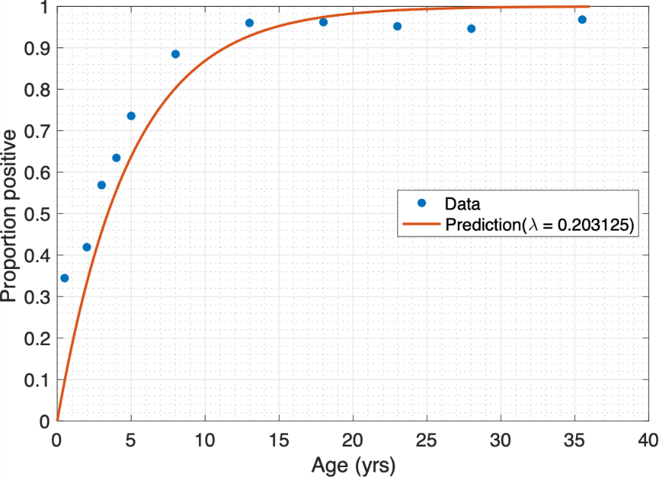

* Force of infection
  + Value : 0.203125
  + Confidence interval : [0.198355 0.208008]
* Average age of infection
  + Value : 4.923077
  + Confidence interval : [4.807499 5.041474]
* R0
  + Value : 12.187500
  + Confidence interval : [11.901282 12.480501]
* Herd immunity threshold
  + Value : 0.917949
  + Confidence interval : [0.915975 0.919875]

1. Modify your expression for the prevalence of previous infection in each age group to deal with maternal antibodies (assume that individuals are immune for the first 6 months of life and are then susceptible), refit the model.

* Plot for a data and prediction plot using best-fitted value

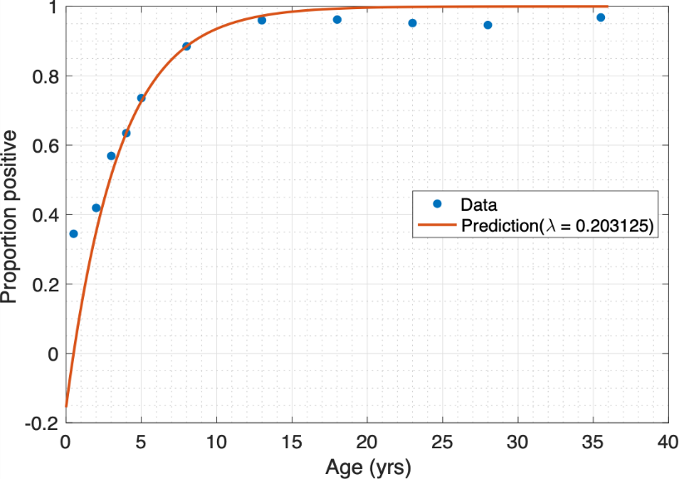

* Force of infection
  + Value : 0.288359
  + Confidence interval : [0.280009 0.296993]

Plot the graphs of –ln(Sa/Na) for the UK and China, where Sa is the number of susceptible at age a and Na is the number of population at age a.

* Plot for the graph of –ln(Sa/Na) for the UK and China

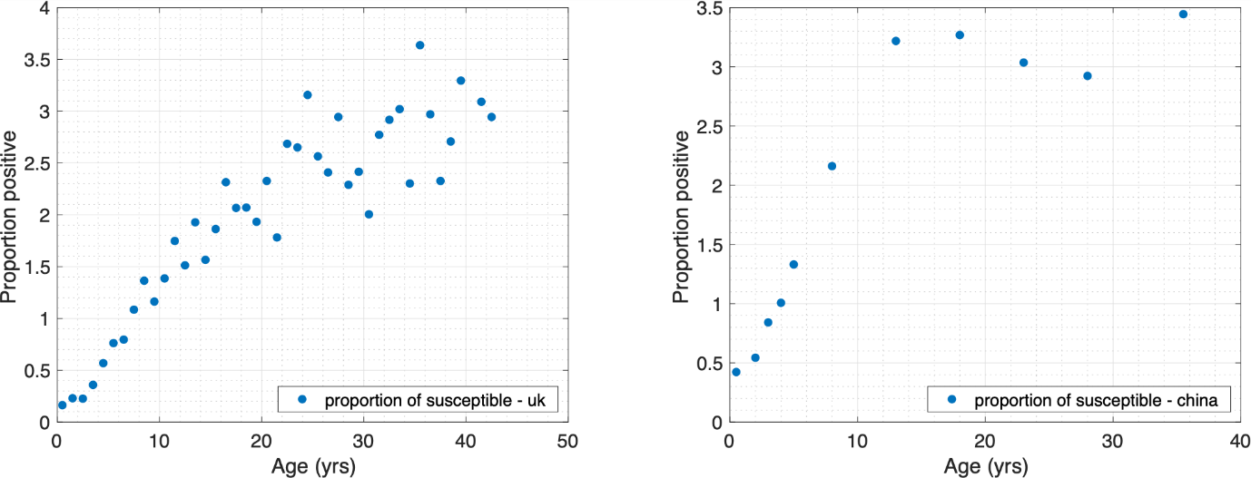

1. Estimate the age-specific forces of infection and 95% confidence interval using 2 age groups for the UK and China. Compare the graphs of model predictions and observed data using constant force of infection and age-specific forces of infection.

* UK

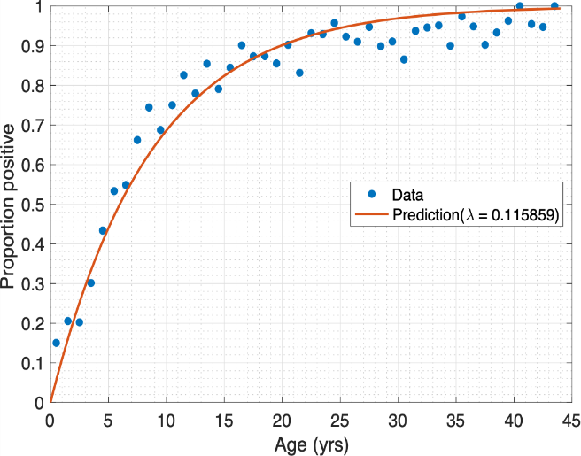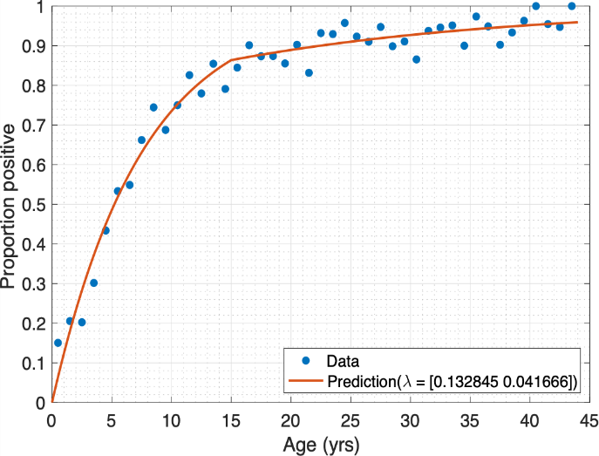

* + Force of infection
    - Value : [0.132845, 0.041666]
    - Confidence interval : [0.124470 0.141629] and [0.023139 0.061888]
* China

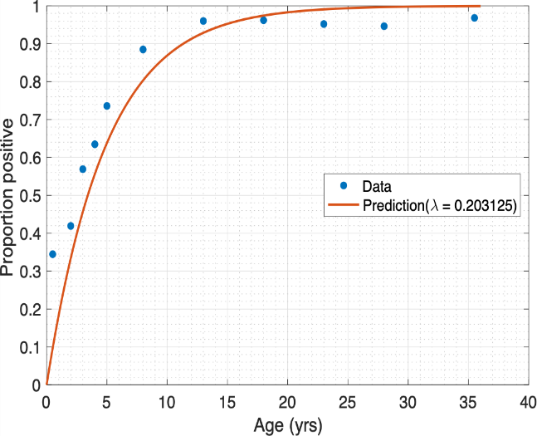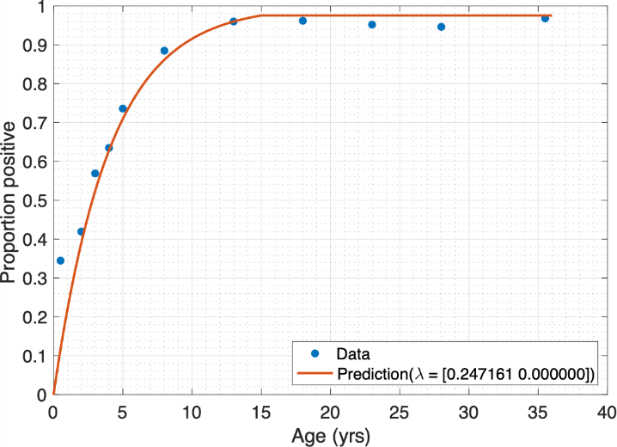

* + Force of infection
    - Value : [0.247161, 7.9058e-11]
    - Confidence interval : [0.240283 0.254252] and [0 2.188769e-3]

**PART Ⅱ: Fitting transmission model to prevalence data to estimate the transmission rate**

Set up the SEIR model of the transmission dynamics of measles in a closed population using differential equations. We assume that individuals mix randomly and parameter and initial values are given as follows:

Population 100000 people

Pre-infectious period 8 days

Infectious period 7 days

Initial values (S,E,I,R)=(99999,0,1,0)

Fit the SEIR model to prevalence data to estimate the transmission rate using MLE in which Poisson distribution is assumed for the data (“prevalence_measles”):

1. What is the best-fitting value for the transmission rate and the 95% confidence interval? Plot a graph of model predictions and observed data.

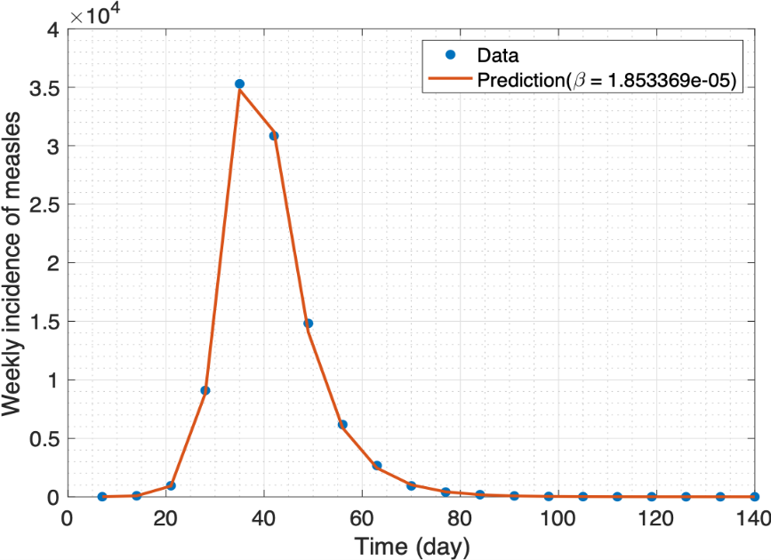

* Best-fitting value of force of infection : 1.853369e-05
* 95% confidence interval : [1.849278e-05 1.857518e-05]

1. Calculate R0 and herd immunity threshold with 95% confidence interval

* R0
  + Value : 12.973454
  + Confidence interval : [12.944819 13.002493]
* Herd immunity threshold
  + Value : 0.922920
  + Confidence interval : [0.922749 0.923092]